Exercise 3: Stored Procedures
Tables:
CREATE TABLE Accounts (
AccountID NUMBER PRIMARY KEY,
CustomerID NUMBER,
AccountType VARCHAR2(20), -- e.g., 'Savings', 'Checking'
Balance NUMBER
);

CREATE TABLE Employees (
EmployeeID NUMBER PRIMARY KEY,
Name VARCHAR2(100),
DepartmentID NUMBER,
Salary NUMBER
);
INSERT INTO Accounts VALUES (101, 1, 'Savings', 5000);
INSERT INTO Accounts VALUES (102, 1, 'Checking', 3000);
INSERT INTO Accounts VALUES (103, 2, 'Savings', 8000);
INSERT INTO Accounts VALUES (104, 2, 'Checking', 2000);

INSERT INTO Employees VALUES (1, 'Alice', 10, 40000);
INSERT INTO Employees VALUES (2, 'Bob', 10, 45000);
INSERT INTO Employees VALUES (3, 'Charlie', 20, 42000);
Select * from Accounts;
Select * from Employees;

Output:

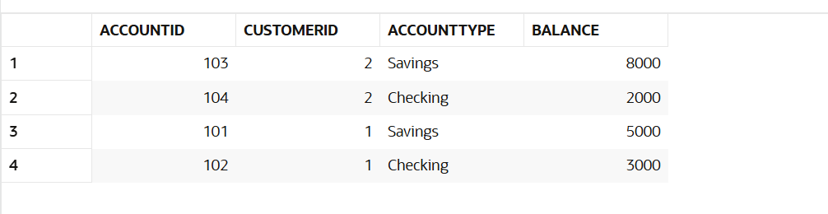

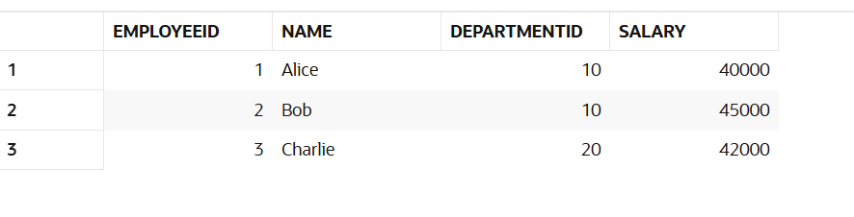
Scenario 1: The bank needs to process monthly interest for all savings accounts.
  - Question: Write a stored procedure ProcessMonthlyInterest that calculates and updates the balance of all savings accounts by applying an interest rate of 1% to the current balance.

Answer:
CREATE OR REPLACE PROCEDURE ProcessMonthlyInterest IS
BEGIN
UPDATE Accounts
SET Balance = Balance + (Balance * 0.01)
WHERE AccountType = 'Savings';

COMMIT;
END;
/

//calling the procedure
BEGIN
ProcessMonthlyInterest;
END;
/

Output(Table after Scenario 1):
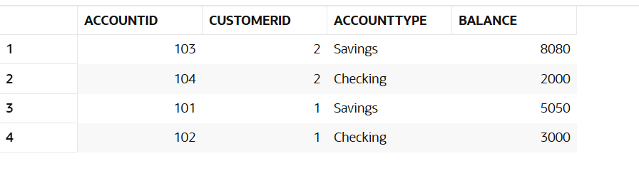

Scenario 2: The bank wants to implement a bonus scheme for employees based on their performance.
  - Question: Write a stored procedure UpdateEmployeeBonus that updates the salary of employees in a given department by adding a bonus percentage passed as a parameter.
Answer:
CREATE OR REPLACE PROCEDURE UpdateEmployeeBonus(
p_DepartmentID IN NUMBER,
p_BonusPercent IN NUMBER
) IS
BEGIN
UPDATE Employees
SET Salary = Salary + (Salary * p_BonusPercent / 100)
WHERE DepartmentID = p_DepartmentID;

COMMIT;
END;

//calling the procedure
BEGIN
UpdateEmployeeBonus(10, 10);
END;
/

Output(Table after Scenario 2):
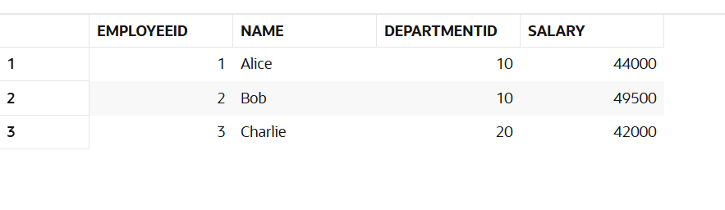
Scenario 3: Customers should be able to transfer funds between their accounts.
  - Question: Write a stored procedure TransferFunds that transfers a specified amount from one account to another, checking that the source account has sufficient balance before making the transfer.
Answer:
CREATE OR REPLACE PROCEDURE TransferFunds(
p_FromAccount IN NUMBER,
p_ToAccount IN NUMBER,
p_Amount IN NUMBER
) IS
v_Balance NUMBER;
BEGIN
SELECT Balance INTO v_Balance
FROM Accounts
WHERE AccountID = p_FromAccount
FOR UPDATE;

IF v_Balance >= p_Amount THEN
UPDATE Accounts
SET Balance = Balance - p_Amount
WHERE AccountID = p_FromAccount;

UPDATE Accounts
SET Balance = Balance + p_Amount
WHERE AccountID = p_ToAccount;
COMMIT;
ELSE
RAISE_APPLICATION_ERROR(-20001, 'Insufficient funds in source account.');
END IF;
END;
/

//calling the procedure
BEGIN
TransferFunds(101, 102, 1000);
END;
/

Output(Table after Scenario 3):
